Quick Guide to the Epson Marking API

The new Epson Marking API is constructed using Microsoft ASP.net technology. It is a RESTful Web API which is running on top of the Microsoft Windows Server 2008 or higher. And its’ required .net framework 4.5 or above.

The following steps describes how to consume the API for testing and accuracy validation.

1. Copy this link <http://172.16.59.252/epson/swagger/ui/index> into the address bar of any Chrome base browser such as: Microsoft Edge, Google Chrome, Mozilla Firefox or Opera. Internet Explorer version 10 and below is not supported. If the browser shown the page as the following screen shot, then click on the ‘MarkingAPI’ from the selection.

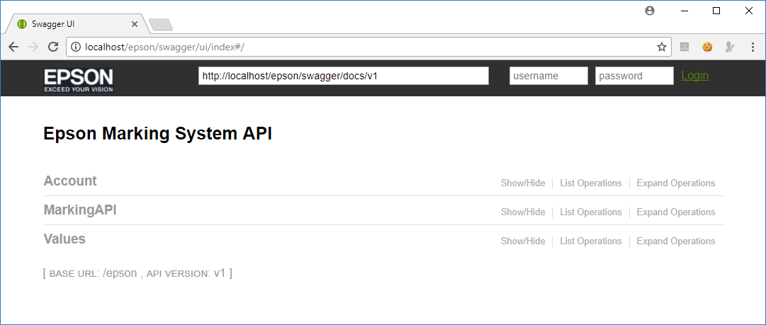

The page will be further expended as shown below. Click on the ‘Get’ method in order to see the function in full page.

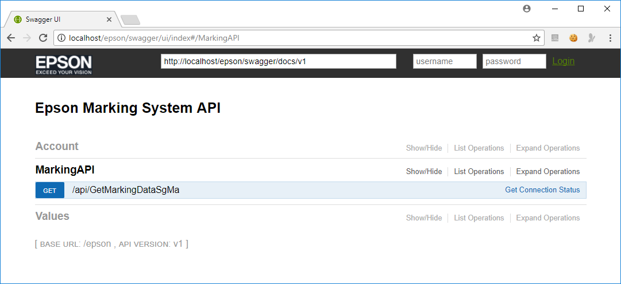

1. Key in the 3 required parameters into the text box provided. Please note that the total length of the ‘Spec No.’ is **12 characters**. The given sample above contain 2 spaces between ‘531PAP’ and ‘03FC’.

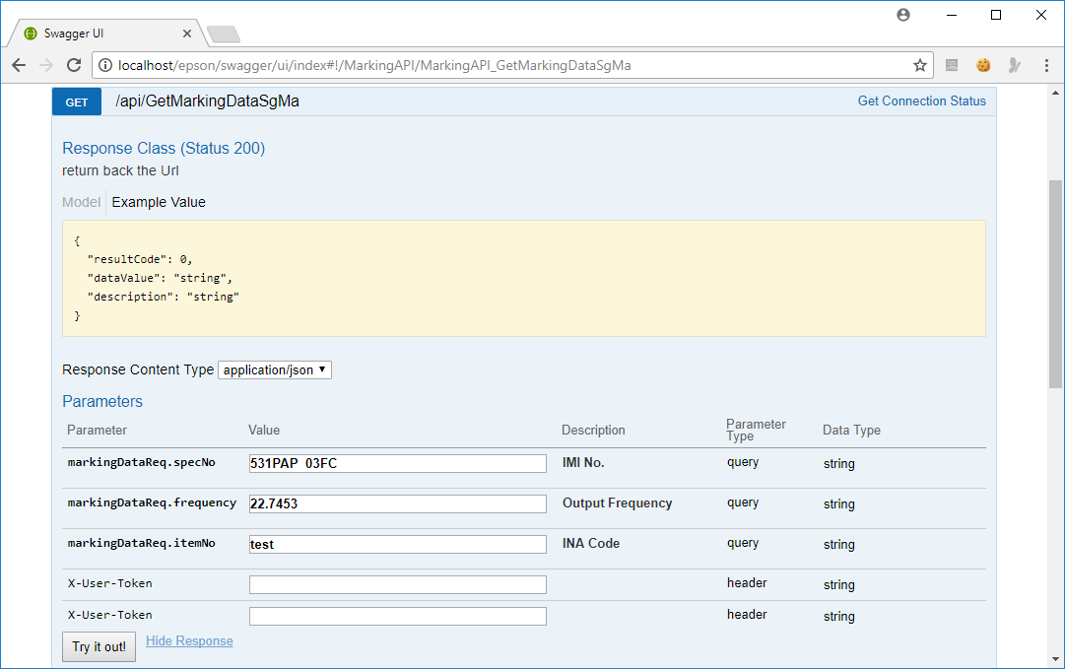

1. Click on the ‘**Try it out**’ button. The page will immediately post a request to the server to obtain a new marking data based on the parameters provided.
2. The server will return the marking data in its response **Http package** as shown below. The field ‘**Data Value**’ is the data which is to be to transfer to the NEC laser unit.

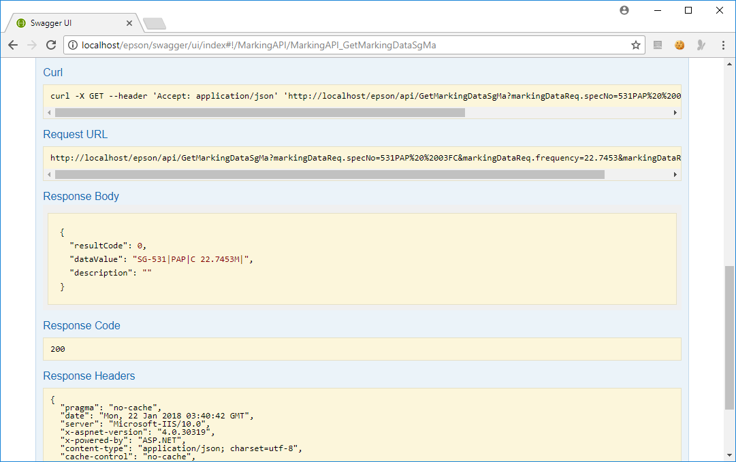

1. If the request and response cycle is complete normally, the response code will be 200. This code will be used by the marking system to identify whether the communication is successful or fail.

